**Design goals**

My initial design goals were to nearly mirror one of the World of Warcraft (WOW) dungeons for a massive multiplayer online role playing game (MMORPG) experience. After careful consideration, I decided to blend the aesthetic of a WOW dungeons in with a small boss arena in the same genre. Then took the inspiration of WOW and the learning tools of class to design a small scale level which will include a mechanic introduction and a boss at the end. Including altitude descent to signify suspense. Using a vista of the playable area to entice the player to traverse the level. And to make the level have a sense of wonder when coming to the boss room, by its’ larger size in comparison to the other segments of the dungeon. To then finish the level with a boss room which is bigger and more important than the others, to signify the finality and resolution to the purpose of the dungeon. With the aesthetic being, to be able to teleport out of the dungeon when the boss is defeated.

**Development log**

26/11/2018

After hearing that this brief asks us to come up with our own genre and assets, I came to the conclusion that is would be easier on the workload to not make too many original assets. I then took from the brief that it would be in our best interest to stick genres of games we are familiar with. For me that meant MMORPG style mainly from the ilk of World of Warcraft. My intention was not to make a full dungeon as that invites many mechanics and a large scope so, I looked around for smaller and more achievable examples. In the end I went with a design of a mountainous volcanic dungeon room with one major goal, a big bad enemy.

3/12/2018

I did research in looking for small dungeons as well as layouts. With looking for the volcanic dungeons from WOW for inspiration.

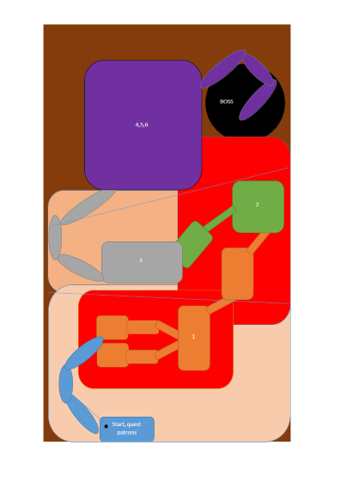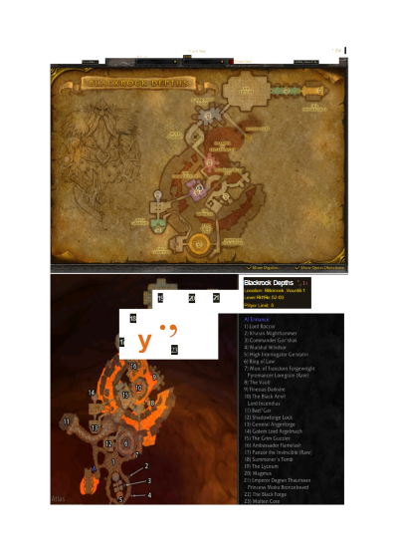

Got Black Rock Depths layout dungeon map from WOW website for reference as a volcanic dungeon.

Spent some time doing a basic layout for the dungeon and pitching a vertical drop as the point of interest.

After class I put together a lighting regime for my dungeon and how my dungeon will be enclosed, with no natural light. So the lighting class came in clutch for putting the colour scheme and placement I was thinking of using for my dungeon.

10/12/2018

After much thought, I pieced together a light box in the vein of only a decent through 4 quadrants. Using it as a stepping stone to a vista effect to the looming boss at the bottom.

Finished first light box of the concept Idea. Not going with a U shape for the dungeon, just a step – bridge - step to final room. I revisited one of our class time exercises and tried to bring a sense of wonder to the final room while eluding to it the entire time (the vista effect).

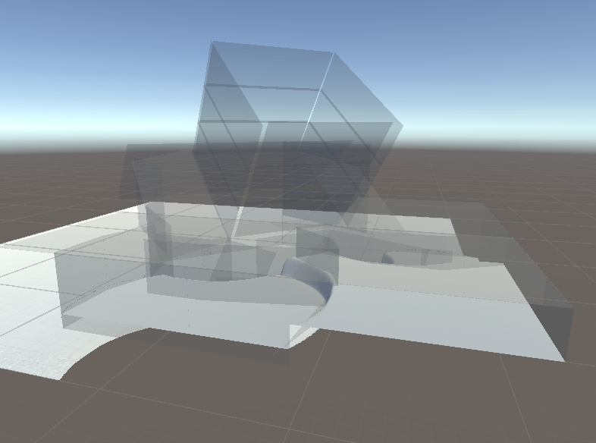

Finalised the design gaols after iterating other design levels. Also crystallising the purpose of the dungeon within the genre.

Iterated the design by adding quality of life and realism to the aesthetic of the dungeon. By adding a chamber for the boss to exit/enter seeing as I’d like the boss to be a dragon, I made a fly in a out zone.

Then had some more thought for design and purpose, the dragon is defending its treasure and protecting its young. Giving the quest givers of this dungeon 3 major quests to fit the MMORPG genre. To slay, retrieve the eggs and collect the treasure with the promise of a magical sword to be forged for you. This will give more purpose the dungeon as well as well aimed ideas of HOW to dress the dungeon.

As the brief says that we can find any assets we wish, I looked on the asset store to find some props worth using to help the aesthetic. I found a treasure chest a dragon to sell the boss.

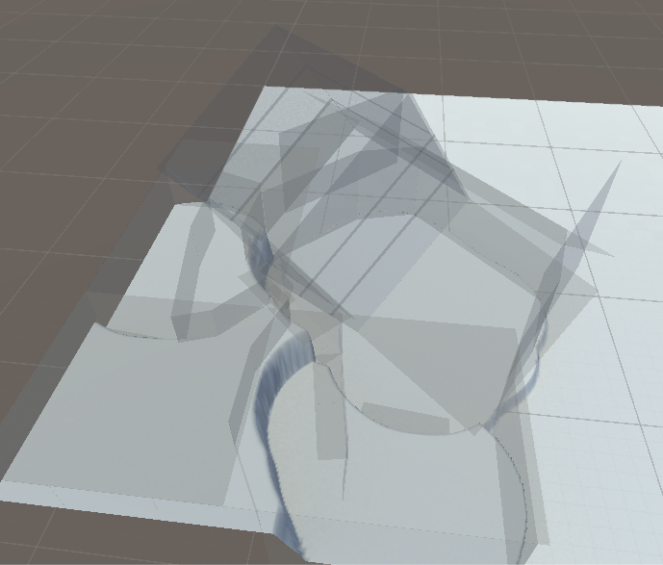

11/12/2018

Started implementing assets to get a base layout from light box. Had a discussion with classmates about practicality and decided to make the turning points of the dungeon a little more acute, making it a more fluid path. By this, shorten some walls and corridors and considering how high the ceiling would be.

Played around with the terrain tool, to create a natural decent to the bottom level.

Also reconsidered how this scene was going to be lit, mostly by torch light and natural light in the boss room.

By using the ancient asset pack, also reconsidered the story for the dungeon, more precisely the placement within the game this is, and what is expected for players. Came to the conclusion that this would be a short high level mid to late game instance where the main focus is defeating a high tier dragon hunting. Aiming to excel at the already established mechanics of a dungeon five manned and give a cinematic to add epic-ness to eh event that is the dragon to slay.

12/12/2018

I finished the base layout for the dungeon using a mixture of the rocks and wall assets to form the path from the light made. Reconsidered the story telling part, so added a narrative path at beginning dividing the opening room in two. Deciding to make it abundantly clear that you must be lead to the torches to witness the cut-scene of the dragon which is your quest.

13/12/2018

Did some final movements of assets to fix up the feel of the play through. Learnt about terrain painting and getting textures for aesthetic within the dungeon. Mixed the terrain textures together to create more cohesive and more immersive gameplay.